GENETIC ALGORITHM

PROCESS OVERVIEW

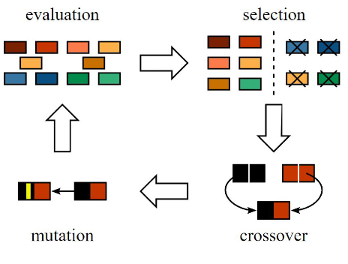A genetic algorithm is solver that uses “evolutionary techniques.” This is done by generating a population of solutions based on genomes (variable subject to change) reacting to a fitness (desired parameter to be minimized or maximized). An effective solution is found, keeping “fit” genomes in a generation and breeding them with other favorable genomes in the following generation, as well as eliminating non-favorable solutions.

This process is very similar to natural selection in the real world since Galapagos iterates, or breeds, multiple generations of solutions until it finds what it believes to be the fittest solution. The image to the left shows the basic genetic algorithm process.

Figure General overview of Evolutionary solver mechanism

GALAPAGOS CONNECTIONS

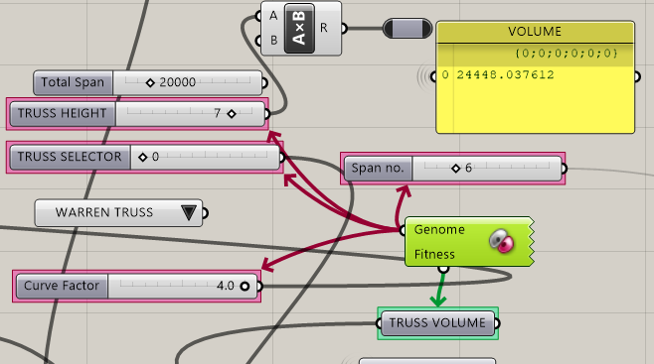The left image shows Galapagos connecting to sliders (maroon arrows) which alter parameters in this file. The fitness connection (green arrow) decides what parameter should be minimized or maximized. In our case, fitness is connected the total volume of the structure.

Figure Galapagos Genome and Fitness connection

GALAPAGOS EVOLUTIONARY SOLVER

Generic :

Fitness Minimize

Runtime Limit 30 minutes

Evolutionary Solver:

Population Size 20 per generation

Initial Boost 2

Maintain Population 5 %

Inbreeding 75 %

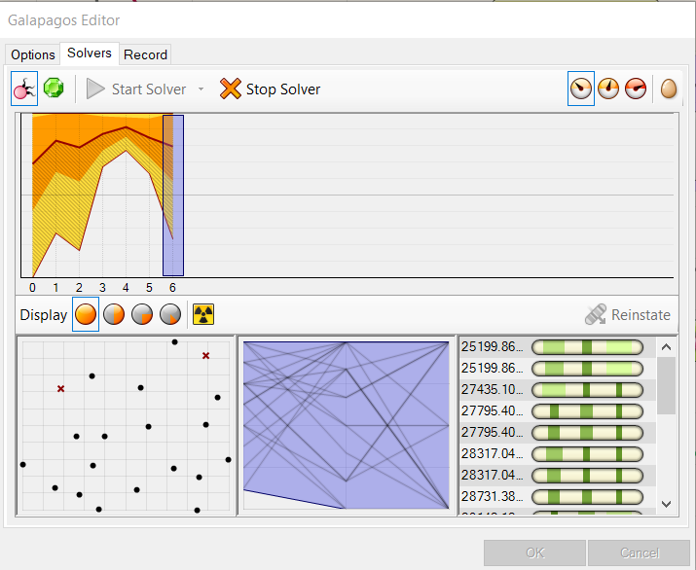

Figure Galapagos Output and User Interface

FITNESS FUNCTION

Minimize ( Fitness ) function of volume

$$\sum_{0}^{n}{(L_{TD}* L_{FD}* \left( 1 + \left(1- C_{BIAS}\right)+ J_{BIAS}\right))}$$

Minimize

where,

L_TD = Length of line in FORM Diagram

L_FD = Length of line in FORCE diagram

C_BIAS = 0.8 for Compressive Force

= 1 for Tensile Force

J_BIAS = 0.05 Joint bias 4% of load on member

CONCLUSIONS:

* The calculations show that weight of a truss for given no. of spans decrease as we increase the height until a certain point from which it decreases. However, higher depths are prone to wind loading and limit buildability, thus are not desired.
* Comparing to straight profile upper chord, parabolic shape of the top chord in truss reduces the overall weight for same topology.
* Combination of Graphic Statics for structural analysis and Genetic Algorithm for optimization can be used with computational ease, to determine the optimum shape of common bridge and roof trusses. The project presents a system that allows users to generate truss shapes and topologies that are efficient for dominant load cases.

FURTHER RECOMMENDATIONS:

* Effect of Buckling and Joints on the structure are represented using bias factors, which could be further refined to more sophisticated cases.
* Load cases in structure is limited to uniformly distributed load, assigned to truss bottom chord endpoints as per tributary length. Further dominant load cases in other directions can be applied for more practical design.
* Optimization of Graphic Static – Force Diagram can result in interesting and construction friendly forms, which are not explored in this study, could be developed.
* Extension of 2d analysis to 3d.
* Considered are determinate and symmetric trusses, which could be further explored for various truss shapes and loading.

ANNEX

ANNEX I – Summary of Truss Types Used in Analysis



ANNEX II – Codes

ANNEX III – Screen Snips for Truss Types

INTERPRETATION OF RESULTS

The results suggest that with increase in the truss height for same span and no. of divisions of span, the fitness value, initially decreases up to a certain point and afterwards the fitness value begins to increase. As the height of trusses increase, they are more prone to wind effects. Thus, height of trusses has been constrained with commonly seen span to depth ratios of 6:1 to 15:1.

For a constant height of a given truss, with the increase in the number of divisions of span, at first fitness value goes on decreasing to certain point then it begins to increase afterward, similar to case where no. of divisions are variable. As for the Pratt truss of Span length 60m and height 10m, its seen that the fitness value at span 4 is 341998 goes on decreasing to 305834 at no. of divisions 8, after which its value increases, as seen in 10 no. of divisions where fitness value goes to 317357.

As seen from the results, the Howe Truss performs significantly poorly than other trusses for dominant UDL load case, in all considered truss cases. Warren truss performs better when top chord profile is straight, whereas, Pratt truss has lower fitness value for same span and height but parabolic top chord profile. For a Span of 60m, and straight top chord profile, Warren truss of height 12m with 8 no. of divisions of span had minimum fitness value compared to other, whereas, for parabolic top chord profile, Pratt Truss of 12m height and 14 no. of divisions of span had the minimum fitness value. The fitness value for these cases change by 10% when top chord profile change to parabolic.

Furthermore, if curvature of top chord is allowed to change, for minimum fitness value truss top chord adopts the shape parabolic arch. In this truss shape, the stresses in the vertical struts are minimized and stresses in the inclined struts are zero. Compared to the truss of same height and horizontal profile, the truss with top chord parabolic for all cases have lower fitness value. The percentage difference between these two shapes range from 15% for 20m span truss of height 8m to 7% for 100m span truss of height 18m. This suggests that arch shape trusses give minimum weight under Uniformly distributed load as dominant load case.